Жеребцов К.А. ИВТ-21

Синтез шифратора и дешифратора

УГО шифратора

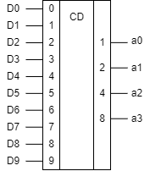

Таблица истинности шифратора для 10 входов:

|  |  |  |  |  |
| --- | --- | --- | --- | --- |
| Десятичное число | a3 | a2 | a1 | a0 |
| 0 | 0 | 0 | 0 | 0 |
| 1 | 0 | 0 | 0 | 1 |
| 2 | 0 | 0 | 1 | 0 |
| 3 | 0 | 0 | 1 | 1 |
| 4 | 0 | 1 | 0 | 0 |
| 5 | 0 | 1 | 0 | 1 |
| 6 | 0 | 1 | 1 | 0 |
| 7 | 0 | 1 | 1 | 1 |
| 8 | 1 | 0 | 0 | 0 |
| 9 | 1 | 0 | 0 | 1 |

ФС шифратора

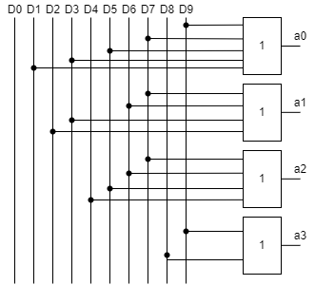

УГО дешифратора

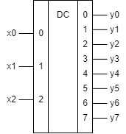

Таблица истинности дешифратора для 3х входов:

|  |  |  |  |  |  |  |  |  |  |  |
| --- | --- | --- | --- | --- | --- | --- | --- | --- | --- | --- |
| Входные сигналы | | | Выходные сигналы | | | | | | | |
| x2 | x1 | x0 | y7 | y6 | y5 | y4 | y3 | y2 | y1 | y0 |
| 0 | 0 | 0 | 0 | 0 | 0 | 0 | 0 | 0 | 0 | **1** |
| 0 | 0 | 1 | 0 | 0 | 0 | 0 | 0 | 0 | **1** | 0 |
| 0 | 1 | 0 | 0 | 0 | 0 | 0 | 0 | **1** | 0 | 0 |
| 0 | 1 | 1 | 0 | 0 | 0 | 0 | **1** | 0 | 0 | 0 |
| 1 | 0 | 0 | 0 | 0 | 0 | **1** | 0 | 0 | 0 | 0 |
| 1 | 0 | 1 | 0 | 0 | **1** | 0 | 0 | 0 | 0 | 0 |
| 1 | 1 | 0 | 0 | **1** | 0 | 0 | 0 | 0 | 0 | 0 |
| 1 | 1 | 1 | **1** | 0 | 0 | 0 | 0 | 0 | 0 | 0 |

ФС дешифратора

